
MeV nEASE tutorial

Downloading and Running MeV
MeV for Windows and Linux requires Java v1.6 or higher to run. MeV for Mac OSX requires Java v1.5 or higher. Download the Java Runtime Environment from http://java.sun.com/ and install it before proceeding with this tutorial.

Download the appropriate version of nEASE-MeV for your operating system from http://www.tm4.org/mev_nease.html. Unzip the downloaded file with Winzip or another unzipping tool. To run MeV on Windows, double-click tmev.bat. To run MeV on Linux/Unix, run tmev.sh. To run MeV on MacOSX, double-click on the MeV application icon.

Loading Data
When you launch MeV, two windows will open. The small narrow window across the top of the screen is called the MeV main menubar. This window is used normally to open new MultipleArrayViewer windows and manage other MeV properties. We will not be using this menubar window for the purposes of this tutorial. The larger window that opens is called a MultipleArrayViewer (MAV). This is where the majority of our work will take place.

Choose File-> Open Analysis from the MAV window. In the file chooser that opens, navigate to the folder where you unzipped MeV, and open the folder called Data. Please select the file ER_status_SAM_1_Miller.anl and choose Open. A saved analysis will be loaded into MeV. This may take some time. These data and the other data files found in the MeV-nEASE package are described more fully in the manuscript. They are based on the data from Miller et al. (2005) and Minn et al. (2005).
Along the left-hand side of the MAV window is a result tree. As you create results in MeV, new icons will appear in this window. Double-clicking on these icons will reveal the result viewers for these analyses.

Running Nested EASE
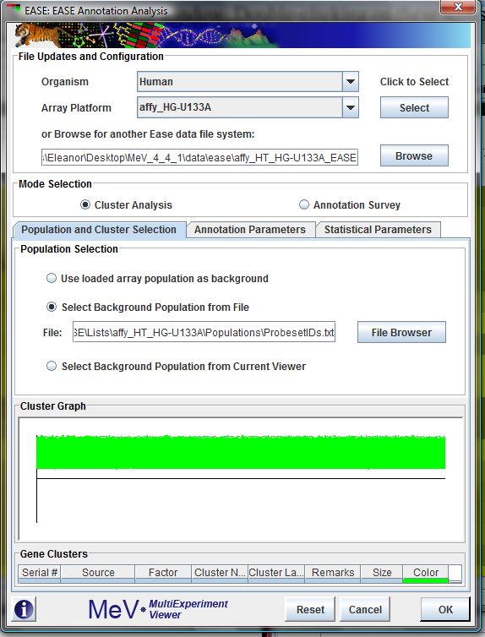
Near the top of the MAV is a row of colorful drop-down menus. These menus contain the analysis options available in MeV. After loading an analysis file, click the Meta-Analysis drop-down menu, and select EASE Cluster Analysis. An initialization dialog will appear.
Figure 1: EASE dialog and Population Panel
Step 1: Selecting the EASE file system
Click the button marked “Browse” and navigate to the folder in the unzipped MeV directory named data\ease\affy_HT_HG-U133A_EASE. You should see three folders inside, Data, Enhance and Lists. Do not select any of these folders. Simply click Open.

Step 2: Population and Cluster Selection Tab
Make sure the option Select Background Population from File is selected. Click the button labeled File Browser and select the file ProbesetIDs.txt.

Step 3: Annotation Parameters Tab
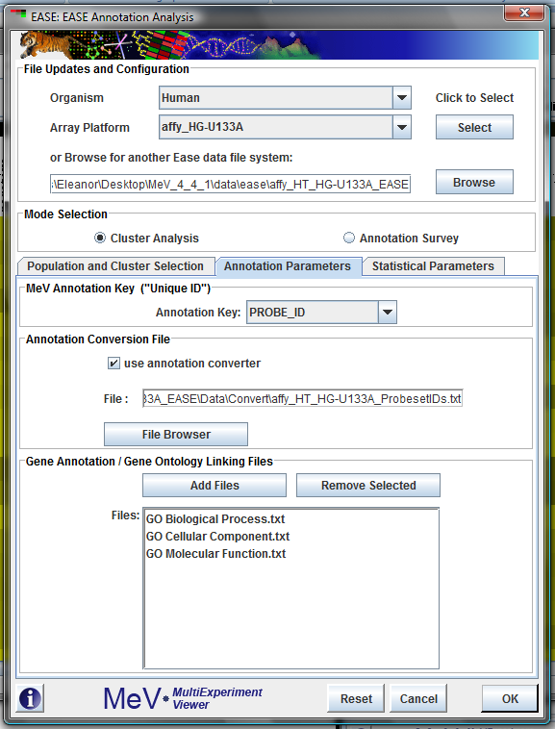
From the drop-down menu labeled Annotation Key, select the heading PROBE_ID. Click the checkbox labeled use annotation converter. Click the button labeled File Browser. The file selection dialog that opens should already be set to the correct directory. (If it is not, navigate from the MeV directory to data\ease\affy_HT_HG-U133A_EASE\Data\Convert.) Select the file affy_HT_HG-U133A_ProbesetIDs.txt.
Figure 2: EASE Dialog and Annotation Panel

In the lower half of the tab, under the heading Gene Annotation /Gene Ontology Linking Files, click the Add Files button. Again, the resulting file browser should already be displaying a list of the available GO term files. (If not, navigate to the data\ease\affy_HT_HG-U133A_EASE\Data\Class directory within the MeV folder.) Hold down the shift key and click on the files, GO Biological Process.txt, GO Molecular Function.txt and GO Cellular Component.txt to select them. When the three files are selected, click Open.
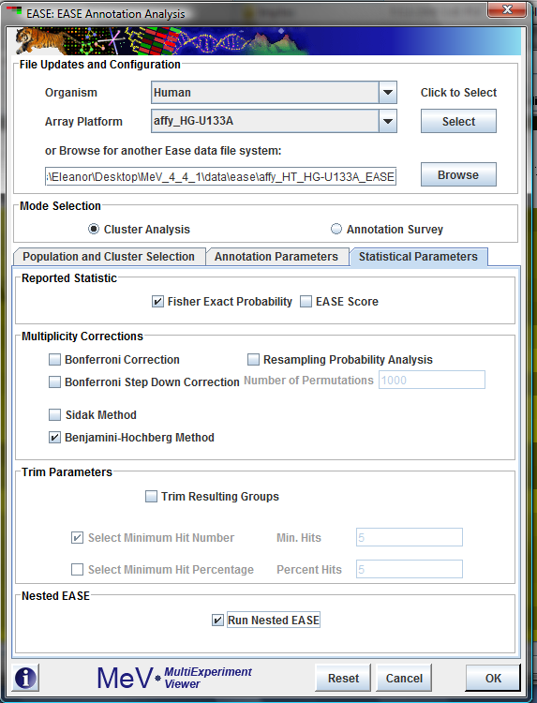
Step 4: Statistical Parameters Tab
Figure 3: EASE Dialog and Statistical Panel
Click to select the check box next to Run Nested EASE, near the bottom of the tab. Insure that the box labeled Benjamini-Hochberg Method is also checked.

Now click the Ok button at the bottom of the initialization dialog to run EASE and Nested EASE. This will take some time.

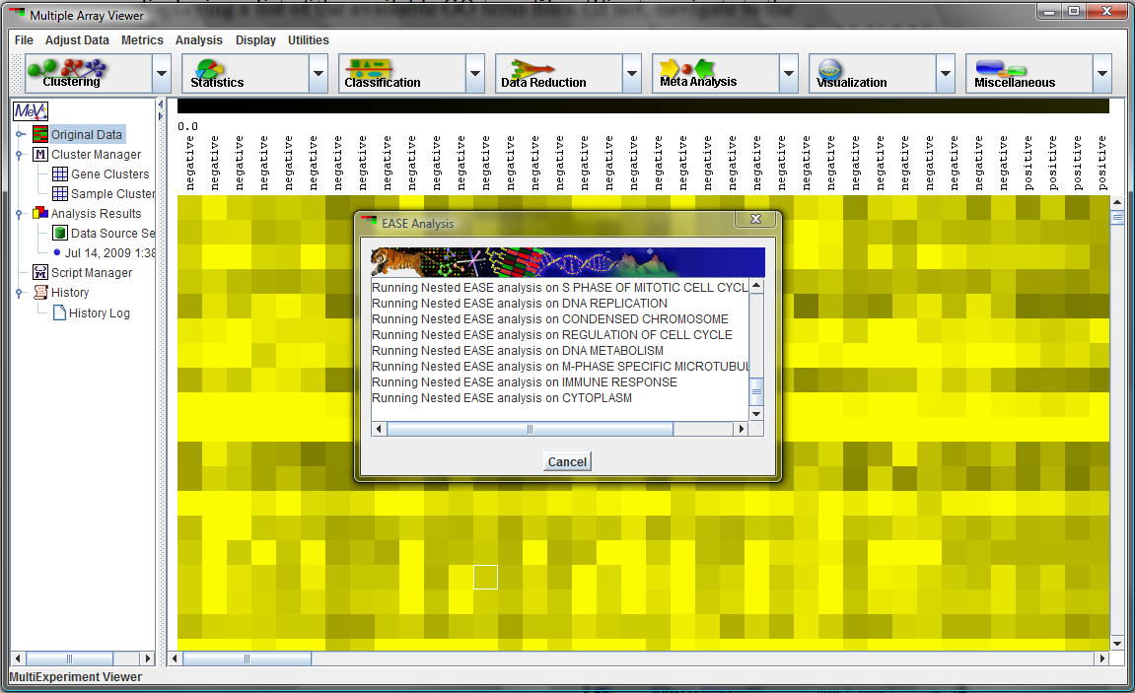
Figure 4: EASE and Nested EASE in Progress. This analysis will take quite a while to run.

Viewing the nEASE results
The standard EASE analysis, as described in Hosack, et al. (2003), will run, followed by the Nested EASE analysis. The nEASE results are included as part of the standard EASE results, as a subnode on the result tree, labeled Nested EASE. Double-click the result node labeled EASE Analysis to see the nested ease results appear.

We recommend that you expand the size of the window containing the Result Tree by clicking and dragging on the dividing bar between the Result Tree and the larger viewing window on the right.
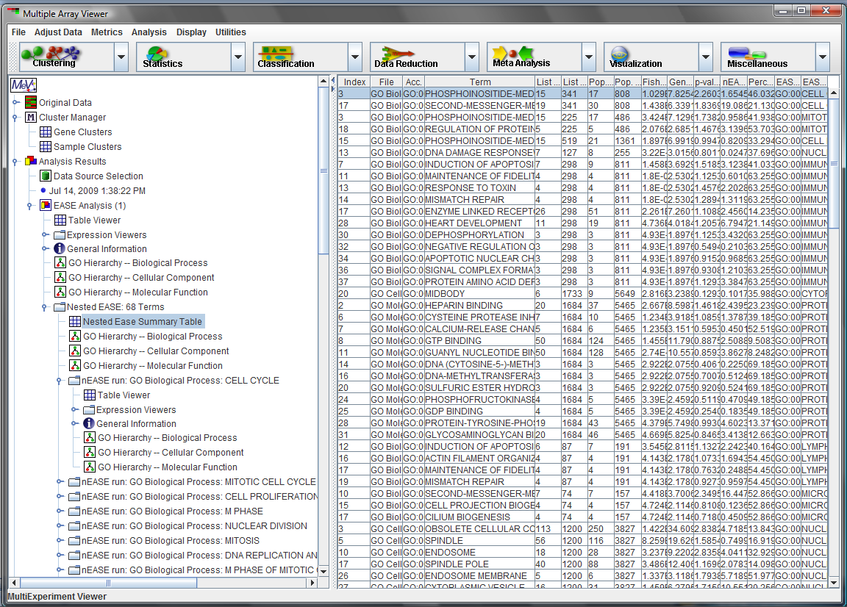
Figure 5: Nested EASE Results. The summary table.
Click on the result nodes to explore the result data within. The most useful view is found in a node labeled Nested EASE Summary Table, which contains the summarized data for all of the nEASE results. These are the data reported in the manuscript.

To examine the genes which drive a result row in the nEASE Summary Table, left-click to select a row, and right-click to open up a context-sensitive menu. Choose Open Viewer -> Expression Image. MeV will open a heatmap view of the probe expression values that correspond to the genes that were members of that group.

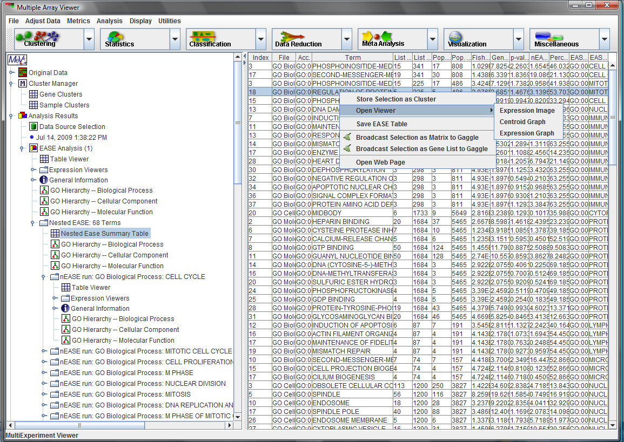
Figure 6: Nested EASE Results. Navigation.

All of the usual heatmap-related options are available in this window, including adjusting the color display, changing the gene annotation displayed, and storing the displayed genes in a new cluster. Note that the left-hand panel, the Result Tree, does not obviously change when this heatmap is opened. However, scrolling the Result Tree down will reveal that a new result node has been selected, corresponding to the Nested EASE result that was selected from the Summary Table.
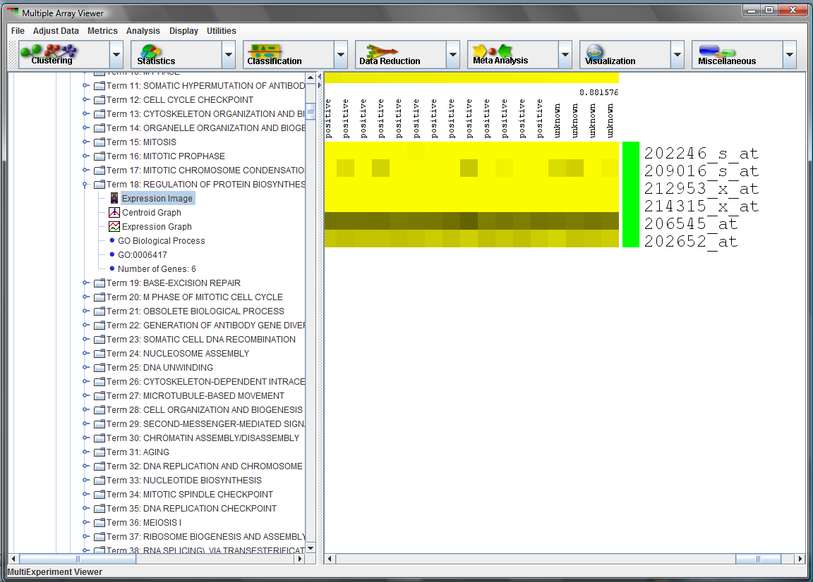
Figure 7: Nested EASE Results. Viewing the individual probe expression values.
References
D. A. Hosack, G. Dennis, B. T. Sherman, H. C. Lane, R. A. Lempicki, Genome Biol 4 (2003).
A. J. Minn, et al. , Nature 436, 518. (2005)
L. D. Miller, et al. , Proceedings of the National Academy of Sciences 102, 13550 (2005).

